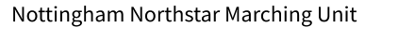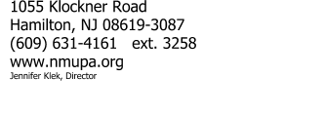

Dear Incoming Marching Unit Students and Parents,

The end of the school year is fast approaching, and it is time to begin preparing for next year’s band activities. We are very excited that you have decided to continue your musical studies as a member of the Nottingham High School Marching Unit and hope that you will enjoy the experience as much as the students who have gone before you.

In order for us to properly prepare for next year we will be sending files of the music and the recordings of the music for practice. In addition, if the building is open in July, we may have a few additional rehearsals with the group.

Band camp this year is held on August 14-15 from 9:00AM-Noon and the weeks of August 17-20 and 24-27 (Monday to Thursday) from 8:00AM to 4:00PM and is required for all marching band members. The activity fee for Band Camp is $50.00. For two students, it is $75.00. This fee helps pay for busing for competitions and also covers the T-shirt they will receive. This year, we will collect the fee in September. Please contact this if you are unable to pay the fee due to extenuating circumstances. We are very flexible.

You will find included with this letter a schedule for next year’s marching unit and a marching unit commitment form. Students wishing to participate in a fall sport and marching unit are allowed to but are expected to coordinate in advance with staff and coaches to split practice time evenly.

As we begin to choreograph next year’s field show it is extremely important that we get an​ accurate number of students participating in marching unit, so we ask that you please fill out​ the Google Forms by May 30th. Please review the schedule and attendance policy carefully before filling out the commitment form. If you have a conflict that would prevent you from attending on June 12th, please send an email to jklek@hamilton.k12.nj.us.

Looking forward to an awesome season!

Jen Klek

