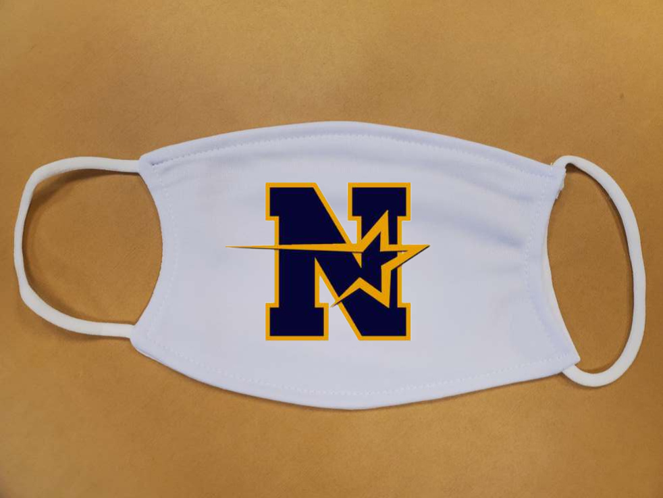

NOTTINGHAM MARCHING UNIT

NHS MASK KITS ~ $15.00 EACH

Washable * Adjustable * 2 Reusable Filters * Poly Cotton

EXACT CASH or
Please Make Checks Payable To: NMUPA

PICK UP ORDERS
35 Saranac Road; Mercerville; 08619

NAME: ______________________________ # of Masks: ______________

Check # _____________ Check Amount _______________

Cash _____________

QUESTIONS: PLEASE CONTACT CHERI JORDINE
Text or Call: 609-462-7402
E-Mail: ccontejordine@gmail.com

